Day-9: 3 Tier Project - Web Tier configuration
- Update your DB server ip here (Private IP)
- This is manually we create a service to start the backend (DB) server from app server instead of going to db and start the service.
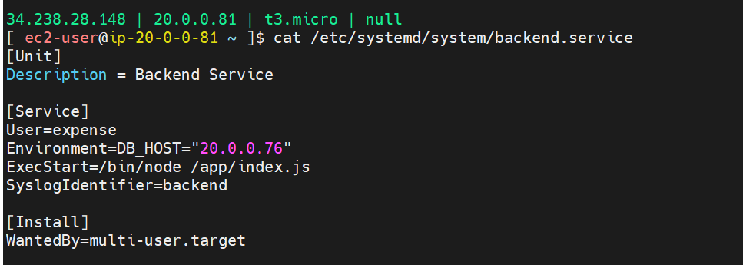

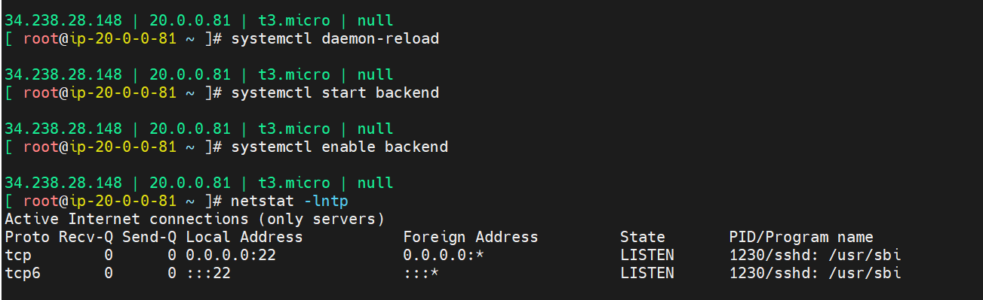

- Service is not started because it is expecting a schema to be created
- Go to logs and verify why it is not started for verification purpose.
- /var/logs – Logs location in Linux
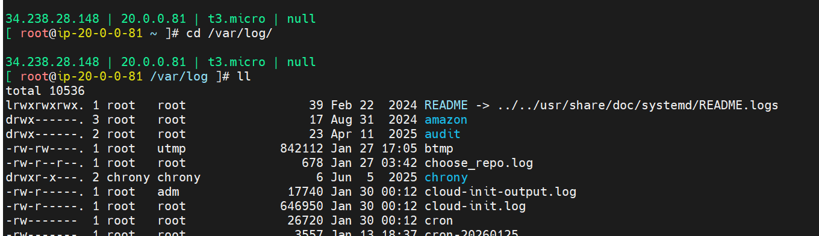
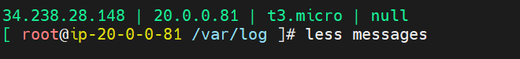
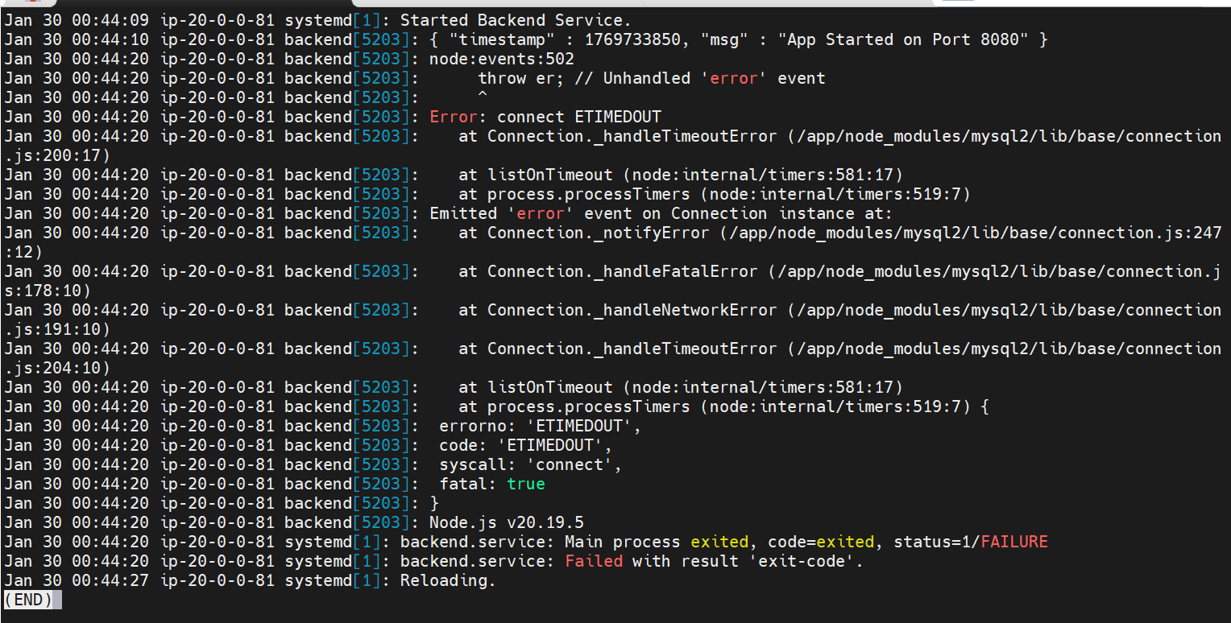
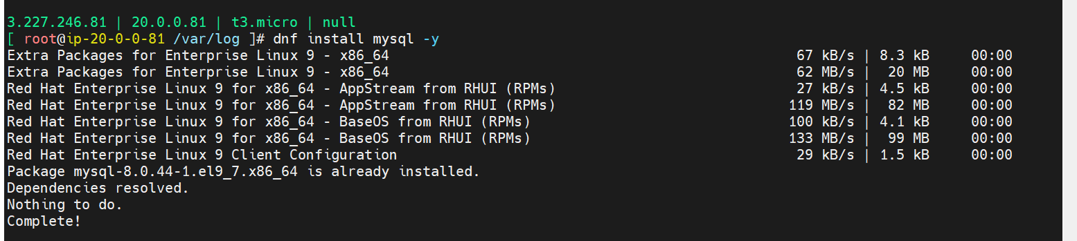
Note: Always use private IP to connect between internal server in same vpc.
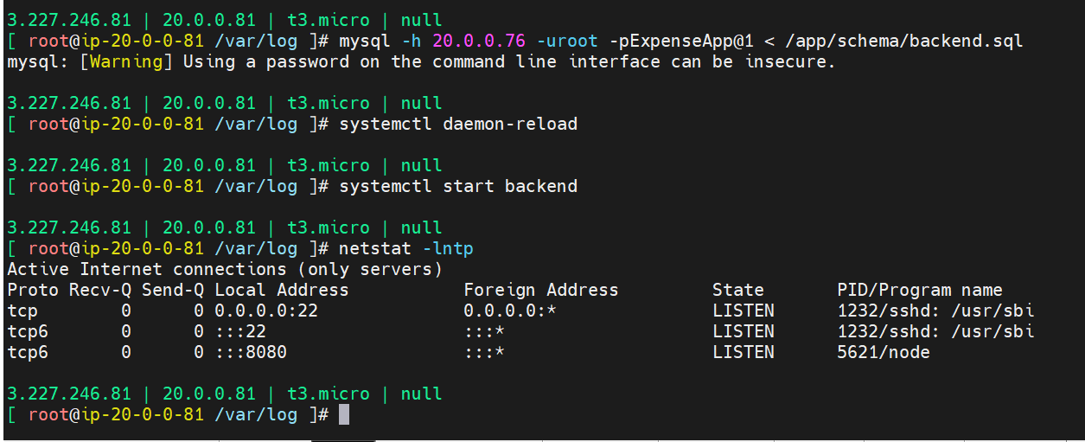

- NGINX:

HTML, CSS and JS -> Is required webserver to run
Required path to know in nginx:
Configs -> /etc/nginx
HTML -> /usr/share/nginx/html
Logs -> /var/log/nginx
Default page -> /usr/share/nginx/html/index.html

- Proxy: on behalf of someone
  - Forward Proxy:
    - Hiding client identity
    - Sits in between client and server
    - Client aware
    - VPN, content filtering, traffic monitoring
    - Can be used as caching also.
  - Reverse Proxy:
    - Hiding server identity
    - Server Aware
    - Security reasons and queue management
    - Load balancing
    - Used for SSL termination

- Configuration in web app:
- Install nginx
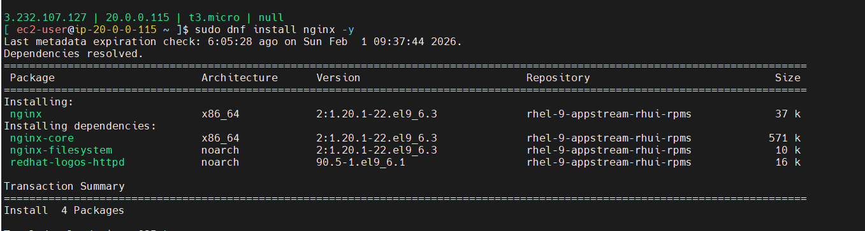

- Remove the existing heml files in nginx and download the project zip file to the following path.
- /usr/share/nginx/html/
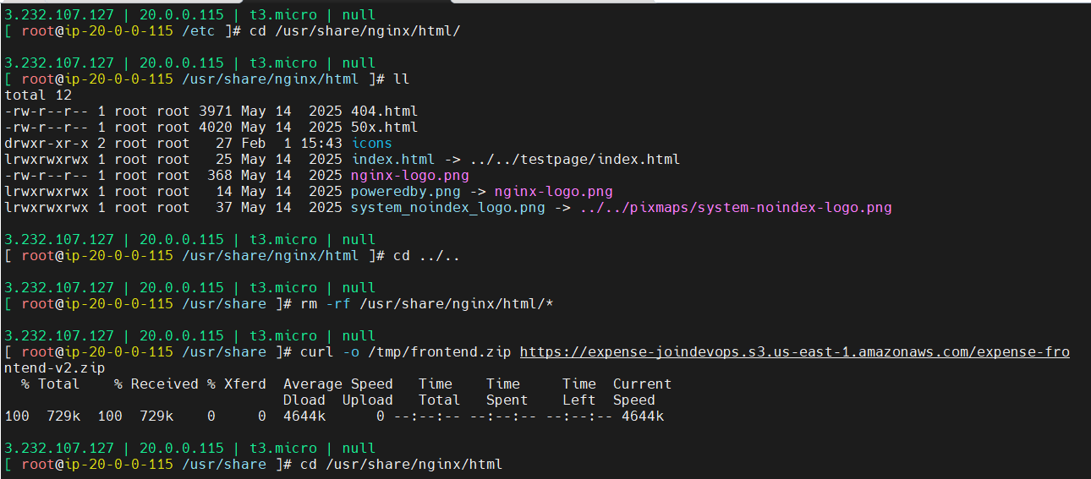
- Unzip the package
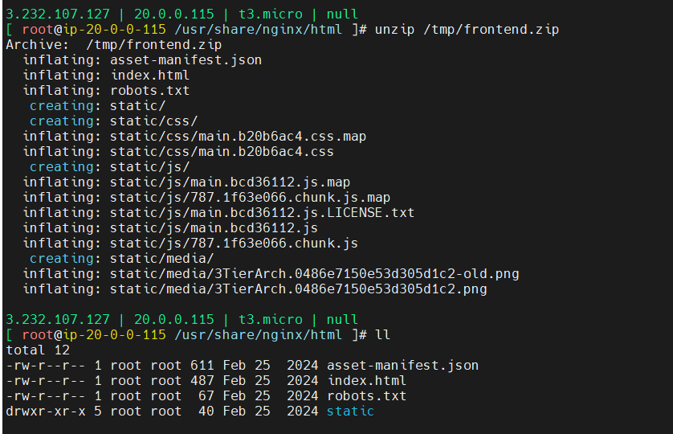

- Then go to the below path for nginx configuration
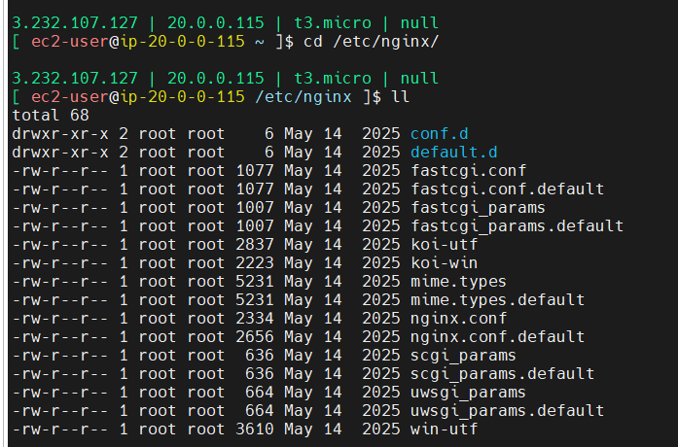
- Create a file in default.d directory “expense.conf”
proxy_http_version 1.1;

location /api/ { proxy_pass http://localhost:8080/; }

location /health {
stub_status on;
access_log off;
}

Note: in localhost , replace with App server private ip

- Then restart the nginx service.

- Now open the browser and enter the link
  - http://web-server-public-ip:80
Note: make suer port, 8080, 80, 3306 are opened in each security group an EC2 for respective Ip to allow.
Make sure you you allowed only private ip subnet. For 8080, 3306
80 to public ip to everyone if required.

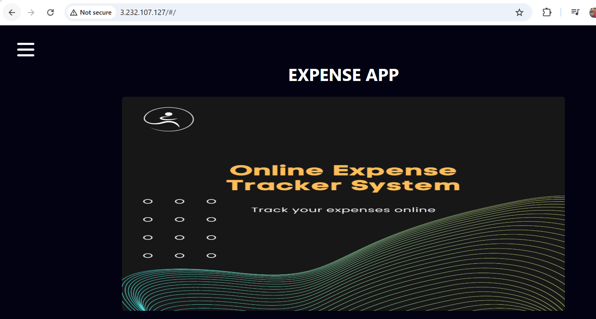
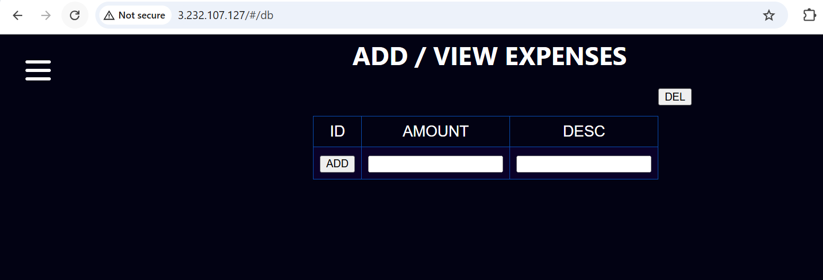

Added 2 values and delete those 2 values again
Verified in databases if values are updating
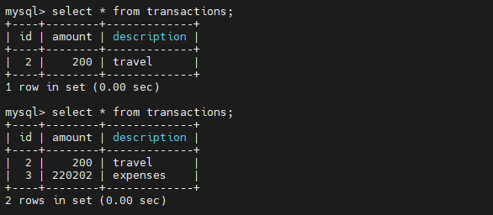

I used same Security Group (SG) for all the 3 server and same vpc , so allowed only private ip subnet range.
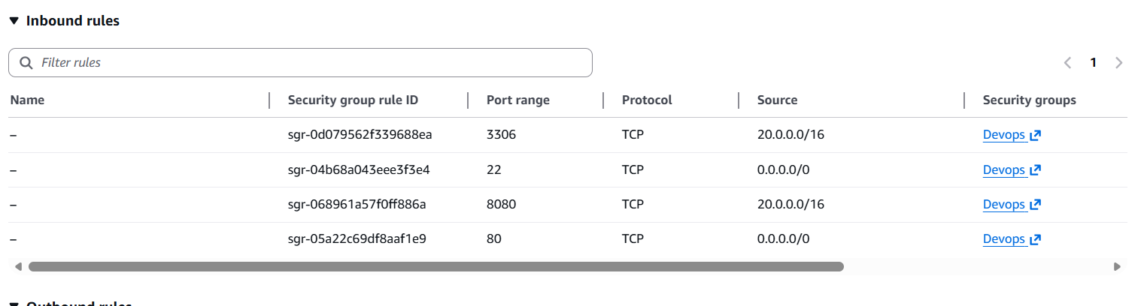

-----------------------------------------------Project End-----------------------------------------------

- Proxy
Proxies in Network Architecture – A Practical View from the Field
In modern network architecture, traffic rarely travels in a straight line from a user to a server. Instead, it often passes through intelligent intermediaries designed to control, protect, and optimize communication. These intermediaries are known as proxies, and they play a critical role in both security and scalability.
For network administrators, DevOps engineers, and IT professionals, understanding how proxies work and where to use them is not optional—it is foundational.

What Is a Proxy (In Simple, Real Terms)
A proxy is a middle layer that sits between a client and a server. Instead of the client communicating directly with the destination, the request is first sent to the proxy. The proxy then decides how, when, and whether that request should reach the destination server.
Once the server responds, the proxy receives the response and sends it back to the client.
This extra hop might seem unnecessary at first, but it enables powerful capabilities such as traffic control, security enforcement, caching, and load distribution.

Forward Proxy – Controlling the Way Clients Reach the Internet
A forward proxy is placed in front of clients, acting as their representative when accessing the internet. External servers never communicate directly with the client; they only see the proxy.
From a network design perspective, a forward proxy is about managing outbound traffic.
When a client sends a request, the forward proxy evaluates it against predefined rules and policies before allowing it to move forward. This gives organizations visibility and control over how users access external resources.
What Forward Proxies Are Commonly Used For
A forward proxy enables administrators to:
- Control which websites or services clients are allowed to access
- Hide the real IP addresses of users to provide anonymity
- Filter content based on security or compliance requirements
- Cache frequently accessed resources to save bandwidth
- Regulate bandwidth usage across multiple users
Where Forward Proxies Are Used in Real Life
Forward proxies are commonly deployed in:
- Corporate networks to monitor and restrict employee internet usage
- Educational institutions to block inappropriate content
- Private networks where servers need controlled internet access
- Privacy-focused setups where users want to mask their identity
In short, forward proxies protect and control clients.

Reverse Proxy – Protecting and Scaling Servers
A reverse proxy sits on the opposite side of the architecture. It is placed in front of servers, receiving incoming client requests and deciding how to route them internally.
From the client’s point of view, the reverse proxy is the server. The real backend servers remain hidden behind it.
Reverse proxies are a cornerstone of modern, scalable production systems.

What Reverse Proxies Do in Production Environments
A reverse proxy helps organizations:
- Distribute traffic across multiple backend servers (load balancing)
- Terminate SSL/TLS connections and reduce server load
- Cache responses and compress content for faster delivery
- Protect backend servers by hiding their IPs
- Block malicious traffic and mitigate DDoS attacks
- Enforce application-level security rules
Reverse proxies are not optional in high-traffic systems—they are essential.

Real-World Use Cases of Reverse Proxy
You will find reverse proxies in:
- Web hosting platforms handling thousands of concurrent users
- E-commerce applications securing payment transactions
- Microservices architectures routing traffic to services
- Content Delivery Networks (CDNs) serving cached content globally
In essence, reverse proxies protect servers and enable scale.

Forward Proxy vs Reverse Proxy – A Simple Way to Remember
Instead of memorizing definitions, think in terms of ownership and protection:
- If the proxy is managing who can go out, it is a forward proxy
- If the proxy is managing who can come in, it is a reverse proxy
Or even simpler:
Forward proxy controls clients.
Reverse proxy protects servers.

Proxies are not just networking concepts; they are design decisions. Choosing the right proxy type directly affects security posture, performance, and scalability.
As systems grow more distributed and security expectations increase, proxies become less of an option and more of a necessity. Understanding them deeply allows engineers to design architectures that are resilient, secure, and future-ready.

